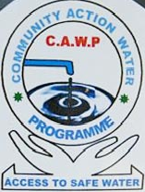

COMMUNITY ACTION WATER PROGRAMME (CAWPO)
WWW.CAWP-SS.ORG

ANNUAL REPORT 2012

COMMUNITY ACTION WATER PROGRAMME
YEI FIELD OFFICE

Juba Road. Contact us on mobiles: 0977108723/0977107898/0955178857
Web site: www.cawp-ss.org

Our Ref: ………………… Date: 18/12/2012

Your Ref: ………………..

Office of A- Commissioner
Director orate of Rural Water
Yei River County
CES

REF: CAWP ANNUAL REPORT FOR THE YEAR 2012 – 2013

Dear Sir,

The attached report is the respond to your circular dated 12/12/2012, as an obligation for national organization to submit their annual activities report to your office.

The attached reports spelt out into details activities carried out by Community Action Water programme within Yei County only, though operation for the year 2012 has been majorly within the three States of Central, Western and Eastern Equatoria States.

The activities carried are:-
- Construction of spring protection
- Drilling of deep wells
- Construction of town mini water yard
- CAWP plan for the year 2013

We hope with these highlights, your office will be of support to CAWP as a national organization in carrying out some of your supported projects E.g. CDF, etc.
Best regards

Vukeni Moses R
Administrator
_________________________________________________
Community Action Water Programme (CAWP)
South Sudan
Mobile: +211 955722044 /+211 977108723 / +256 782435140
Skype: vukeni.moses Email: vukeni.moses@cawp-ss.org
Web page: www.cawp-ss.org

REF: THE FIVE LAST SPRING WALLS PROTECTED IN LASU PAYAM

Background information of the last Five Spring:
The five last springs which was not completed last year remain in their previous sited location of Lasu Payam.
Earlier this year 2012 CAWP management started the remobilization of resources, personal and the material for the continuation of the spring project in Lasu payam. CAWP Managing Director early February 2012 went on the ground and held a meeting with the local authority of Lasu Boma. He assured them of CAWP commitment to accomplish the project of the spring protection which was not completed in the previous year in Lasu Payam. He argued the local authority for their support to reinforce CAWP Technicians in accomplishing the project. He also told them the challenges the organization is facing with logistics, high prices of industrial materials and custom charges on the imported materials from the neighbouring country.
During the meeting CAWP Director assured to the local authority the immediately resume of the project.

IMPLEMENTING STRATEGY

On 21/02/2012 the spring technician were on the ground and resumed the spring construction work at the first site Lalesa by conducting the follow activities

- Clearing of the surrounding
- Mobilizing and transportation of the local material to the site
- Setting and excavation of the collection box and water drainage system
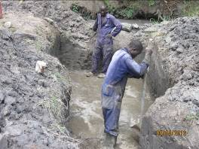
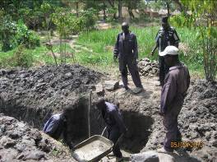

- pouring concrete slab for the base foundation of the springs
- Building of the retail wall and covering up the main source of the springs with stone and aggregates
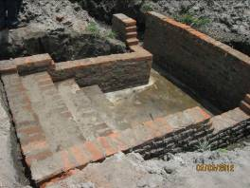

- Flustering the walls and opening the water pipe for the beneficiaries to start using the water points
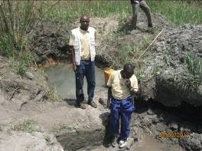
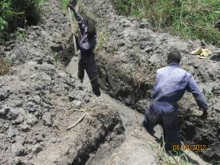

PROBLEM ENCOUNTER DURING THE IMPLEMENTATION

The heavy continue rains experienced in 2011 and the political wave of referendum campaign, the preparation for the declaration of the Republic of South Sudan has robbed some of our times during the implementation process of this project. As a national organization we were part and partial of the activities that was happening during the preparation for birth of the new Nation.

- Scarcity of local materials within the project area that has resulted into buying the locals material from a distant location.
- Inaccessibility of road leading to the local material site.
- Breakdown of the support truck in ferrying the local materials
- Conflict over the allocation of the spring site. The few distributed water points were not enough to cover the entire population of Lasu Payam.
- Increase in the population due the returnees coming back home from the northern Sudan and the neighbouring Counties.
- More refugees are running from Congo to South Sudan settling within Lasu Payam.
- With the changes in the Country local community are demanding for payment for their contribution as well as for the local material specially stone (aggregates)

ACHIEVEMENT

- Ten successful spring wells constructed 5 in 2010 and 5 this year, fully in use by the community of Lasu Payam in their respective locations.

- Water scarcity problem in the village has been reduce by 40% at least vulnerable people old women and girl child could rust and fetch water with no much delay

- in-order to catch up with class in the school.
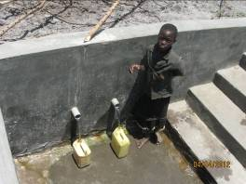
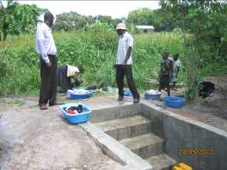

- Conflict over water point mostly by women during the morning and evening hours has been minimised. Women now can collect water from their own village springs without causing problem to one another.

- Water born diseases and other water related sickness which was caused by the unsafe water sources has been reduce with 53% compare to the previous years when CAWP constructed the first five springs which were been share by the Congolese refugees from DRC
- School children, market people and the near by army barrack could not now struggle or suffer like before travelling for long distant looking for water. The Acholi Boma spring is serving these groups of people.

- The availability of clean water in the areas has accelerated agricultural activity; water point committee could irrigate their vegetables with the free flow water

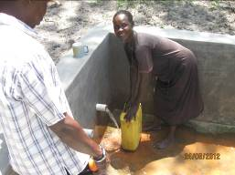
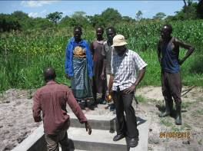

from the springs. And this has been initiated by head man and the paramount Chief of the Payam.

- The picture below is the paramount chief and his Head man who initiated such activities in one of the spring site.

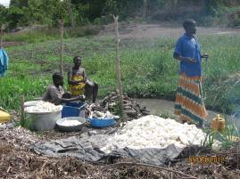
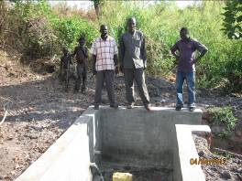

Lesson learned during the project implementation and Recommendations.

- The longer the project last, the costly it becomes to the organization.

- Joint monitoring/supervision of a project by the three parties give weights to the implementers and assurance of accountability to the beneficiaries.

- Community participation with the current economical crisis in the country has slow down the contribution of the community beneficiaries.
- Springs protection wells are cheaper to construct and maintain compare to deep well drilling.
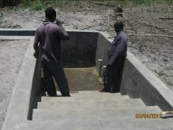
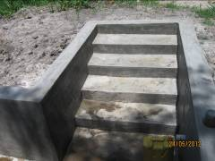

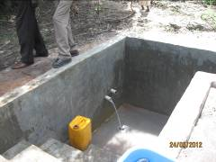

Drilling:
Community Action Water Programme has implemented the following project in Yei County 2012, to the mentioned client. Successfully drilled boreholes and installed with India Mark II hand pump,

- CDF borehole drilled in Moraju village, pakula boma Yei Payam on the 09/05/2012
- SUHA boreholes drilled in Randukwe village Longamere boma Mugwo payam on the,19/02/2012
- SUHA boreholes drilled in LUN Host village Payawa boma Mugwo payam, on the 24/02/2012.
- SUHA boreholes drilled in Goli village, Mongo boma Otogo Payam on the 22/05/2012
- Community borehole funded by Rubeke community leader, drilled at Molule village Rubeke boma Otogo Payam on the 16/07/2012
- IAS borehole drilled in Marakonye village Gimunu Boma Yei payam on the 14/1/2012
- IAS borehole drilled in Marakonye Church, Gimunu Boma Yei Payam on the 23/1/2012.
Challenges encountered during drilling.
- High cost of drilling materials
- High taxes on the imported drilling materials
- Bed roads leading to the drilling site
- Heavy rain through out the region hindering the movement of trucks
- Spare part for the drilling machines are not within the country.
- Lack of county support to the national organisation of term of projects

Mini Water yard.

CAWP, management took initiative of setting up the above mentioned project at the new proposed market sit at Lutaya through the approval of Payam Director and County MP for solving water problem at the new market site.

Upon the approval of documentation for the project to start CAWP did sit survey for borehole and drilled a high yield borehole which was installed with submersible pump that pump water to the over head tank with a capacity of 10,000 litres.

The overall objective of this project is provision of safe potable water to our business women and man for the commercial activities within the market square and beyond.

Below is the photo of the mini water yard funded and constructed by Community Action Water programme (CAWP)

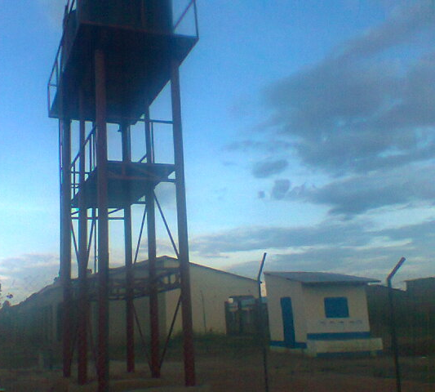
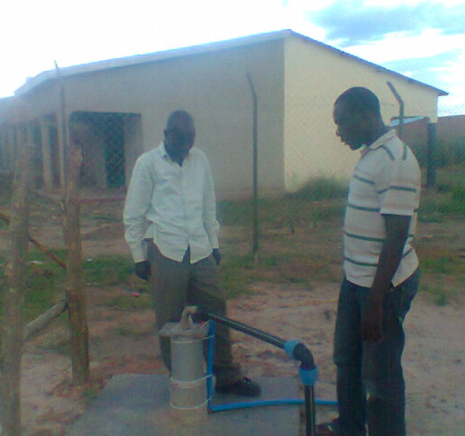

The over head Tank with capacity of 10,000litres. And the submersible pump installed

Challenges on the establishment of Lutaya market water supply system.
- Mobilization of resource and materials for the construction of the mini water supply system was very short
- High price of construction materials
- Lack of government power supply to run the water system
- There is more need for extension of kisoh to meet the need of water supply to other users.

CAWP WORK PLAN FOR THE YEAR 2013
- Staff conference/workshop in January 2013 Yei County
- Board meeting January
- Renewal of vehicles licences and log books
- Strengthening of Juba office.
- Proposal writing and lobbing for government funding through County support. February- April
- Applying for any bidding from the partners
- Completion of drilling in Easter Equatoria Pageria Payam – January
- Drilling of one borehole in Lainya county
- Construction of five spring well in Yei county incase any funded avail – March- April
- Training of water user and pump mechanics technicians – July
- Attending WASH co-ordination meetings both at state level and regional.
- Report writing – quarterly and annual

